AI ASSISTED LAB ASSIGNMENT-6.1

NAME: J.Bhargavi

BATCH:14

ROLL_NO:2503A52417

Task-1: (AI-Based Code Completion for Loops)

Prompt:

“Generate Python code to print all even numbers between 1 and N

Using a loop.”

Input:

#Generate Python code to print all even numbers between 1 and Nusing a loop.

N = int(input("Enter a number: "))
print("Even numbers between 1 and", N, "are:")
for i in range(1, N + 1):
if i % 2 == 0:
print(i)

output:
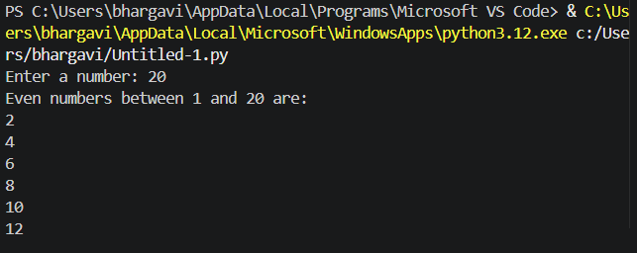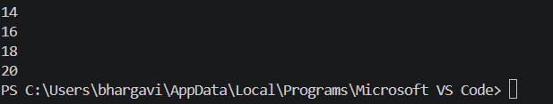

Task-2: (AI-Based Code Completion for Loop withConditionals)

Prompt:

“Generate Python code to count how many numbers in a list are even

and odd.”

Input:

def count_even_odd(numbers):
even_count = 0
odd_count = 0

for num in numbers:
if num % 2 == 0:
even_count += 1
else:
odd_count += 1

return even_count, odd_count

# Example usage
numbers_list = [1, 2, 3, 4, 5, 6, 7, 8, 9, 10]
even_count, odd_count = count_even_odd(numbers_list)
print(f"Even numbers count: {even_count}")
print(f"Odd numbers count: {odd_count}")

output:
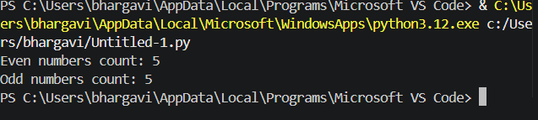

Task-3: (AI-Based Code Completion for Class Attributes Validation)
Prompt:
“Generate a Python class User that validates age and email using conditional statements.”

Input:

class User:
def __init__(self, name, age, email):
self.name = name
self.age = age
self.email = email

def validate_age(self):
if self.age < 0:
return "Age cannot be negative."
elif self.age < 18:
return "User is a minor."
else:
return "User is an adult."

def validate_email(self):
if "@" not in self.email or "." not in self.email:
return "Invalid email format."
else:
return "Email is valid."
# Example usage:
user1 = User("Alice", 25, "alice@example.com")
print(user1.validate_age()) # Output: User is an adult.
print(user1.validate_email()) # Output: Email is valid.

Output:
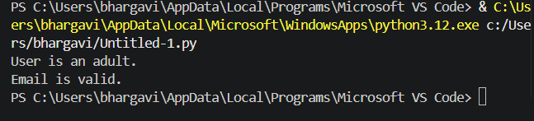

Task-4: (AI-Based Code Completion for Classes)
Prompt:
“Generate a Python class Student with attributes (name, roll number, marks) and methods to calculate total and average marks.”

Input:

class Student:
def __init__(self, name, roll_number, marks):
self.name = name
self.roll_number = roll_number
self.marks = marks

def calculate_total(self):
return sum(self.marks)

def calculate_average(self):
total = self.calculate_total()
return total / len(self.marks) if self.marks else 0

# Example usage:
student1 = Student("Bob", 101, [85, 90, 78, 92])
print(f"Total marks for {student1.name}: {student1.calculate_total()}")
print(f"Average marks for {student1.name}: {student1.calculate_average()}")

output:
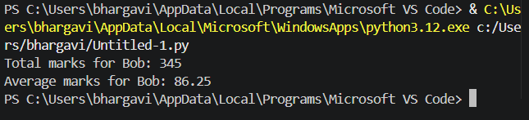

Task-5: (AI-Assisted Code Completion Review)
Prompt:
“Generate a Python program for a simple bank account system using class, loops, and conditional statements.”
Input:

#Generate a Python program for a simple bank account system usingclass, loops, and conditional statements.
class BankAccount:
def __init__(self, account_number, account_holder, balance=0):
self.account_number = account_number
self.account_holder = account_holder
self.balance = balance

def deposit(self, amount):
if amount > 0:
self.balance += amount
print(f"Deposited: ${amount}. New balance: ${self.balance}.")
else:
print("Deposit amount must be positive.")

def withdraw(self, amount):
if amount > 0:
if amount <= self.balance:
self.balance -= amount
print(f"Withdrew: ${amount}. New balance: ${self.balance}.")
else:
print("Insufficient funds.")
else:
print("Withdrawal amount must be positive.")

def check_balance(self):
print(f"Account Balance: ${self.balance}.")
#give example usage
if __name__ == "__main__":
# Create a new bank account
account = BankAccount("12345", "John Doe", 1000)

# Check initial balance
account.check_balance()

# Deposit money
account.deposit(500)

# Withdraw money
account.withdraw(200)

# Check final balance
account.check_balance()

Output:


